# **Title: Space Crusade**

1. **Genre:** Shooting
2. **High Concept:**

The concept of this game is to avoid oncoming asteroids and various waves of enemies that will progressively get harder as time and levels progress. The main objective will be to save escape pods and fight off enemies trying to destroy both the pods and you at the same time.

1. **Back Story:**

In a year far in the distant future when space travel is fully developed. An interstellar cruiser named “The Crusade” is hit under heavy fire by alien pirates trying to destroy and salvage the ship for parts and treasure. The ship was unable to withstand the enemy’s superior weaponry and thus moves into an asteroid field to abandons ship.

It is now up to the galactic fighter squadron to rescue the crew from the escape pods and bring them back to safety in the confines of the fighter ships. The number one priority is to try and not leave anyone behind.

The alien pirates deploy there fighters as well in an attempt to prevent this from happening. They are not only hunting for you, but the escape pods as well.

1. **Target and Platform:** Ages 8+, and Mac
2. **Game Play:** The objective of the game is to save the crew in the escape pods while trying to avoid oncoming asteroids and alien pirate ships. The goal is to save 10 (level 1), 15 (level 2), and 20 (level 3) escape pods. There will be different aspects to the game as well that will allow the ship to make upgrades by killing enemies or finding new weapon/ship upgrades from “The Crusade’s” debris.
3. **USP (Unique Selling Proposition):**

* This type of game appeals to audiences who are interested in a good back story and determined to complete without any error.
* This game will also appeal to audiences who like games played in space with cool new fresh sprites.
* Passing the 3 starter levels will unlock an “Endless” mode to test the skill of the player and see how long they can last under the constant chaos thrown at them.

1. **Competitive Analysis:** List up three similar games (name, web, screen shot image)

* **sample 1 –** Asteroids (Atari classic game)

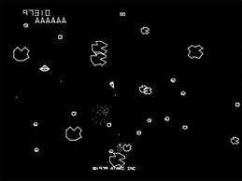

* **sample 2 –** Space Invaders (Atari classic game)

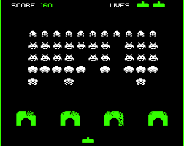

* **sample 3 –** Galaxy Attack: Alien Shooter

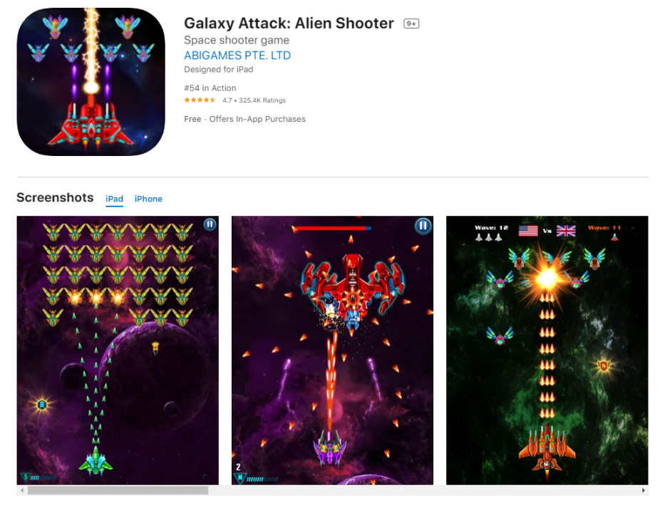

1. **Budget:**

**N/A**

1. **Members:**

**Name:** Jeffrey Adams

1. **Summary:**

In summary, the goal of this game will be to save the crew who abandoned ship before they are destroyed by alien pirates. In order to save the crew, you must avoid oncoming asteroids and fend off against incoming alien pirates trying to attack you. During the game you might find some helpful ship upgrade’s that will aid in the rescue. The more escape pods saved may also increase the stability and recharge of the ship’s shields. If even one escape pod is lost the mission is over and will restart. Your levels will save as you go but get harder after each level. Once the 3 main levels are completed a final level will be unlocked and will allow you to go endlessly to test your skill in the heat of battle.

1. **Concept Arts:** Copy and Paste some sketches



